CPVC
Submittal Information

CPVC 90 Degree Tee Saddle

- Constructed from CPVC Duct For Use In
Ventilation Systems

- Fitting Pieces Triple-Pass Welded Using 5/32”
PVC Welding Rod

- All Dimensions in Inches
- All Dimensions are to CSSI standards and are
Subject to Change

PRODUCT DIMENSIONS
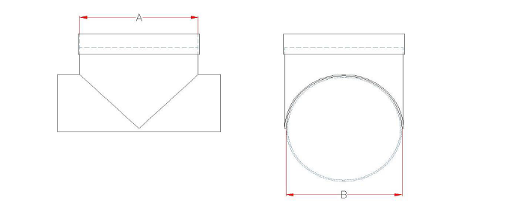
CPVC 90 DEGREE TEE SADDLE SUBMITTAL INFORMATION

Model Number Nominal Reducer Size A B “B”-End Type
SA90-6-6 | 6 ON 6 | 6.625 + 1/16 | 6.625  SOCKET
SA90-6-7 | 6 ON 7 | 6.625 + 1/16 | 7.375
SA90-6-8 | 6 ON 8 | 6.625 + 1/16 | 8.625
SA90-6-9 | 6 ON 9 | 6.625 + 1/16 | 9.375
SA90-6-10 | 6 ON 10 | 6.625 + 1/16 | 10.75
SA90-6-12 | 6 ON 12 | 6.625 + 1/16 | 12.75
SA90-6-14 | 6 ON 14 | 6.625 + 1/16 | 14
SA90-6-16 | 6 ON 16 | 6.625 + 1/16 | 16
SA90-6-18 | 6 ON 18 | 6.625 + 1/16 | 18
SA90-6-20 | 6 ON 20 | 6.625 + 1/16 | 20
SA90-6-24 | 6 ON 24 | 6.625 + 1/16 | 24
SA90-7-7 | 7 ON 7 | 7.375 + 1/16 | 7.375
SA90-7-8 | 7 ON 8 | 7.375 + 1/16 | 8.625
SA90-7-9 | 7 ON 9 | 7.375 + 1/16 | 9.375
SA90-7-10 | 7 ON 10 | 7.375 + 1/16 | 10.75
SA90-7-12 | 7 ON 12 | 7.375 + 1/16 | 12.75
SA90-7-14 | 7 ON 14 | 7.375 + 1/16 | 14
SA90-7-16 | 7 ON 16 | 7.375 + 1/16 | 16
SA90-7-18 | 7 ON 18 | 7.375 + 1/16 | 18
SA90-7-20 | 7 ON 20 | 7.375 + 1/16 | 20
SA90-7-24 | 7 ON 24 | 7.375 + 1/16 | 24

