CPVC
CPVC Butterfly Damper

Submittal Information

- Constructed from CPVC Duct and Type I CPVC Sheet
For Use in Ventilation Systems

- Welded Construction using 5/32” CPVC Welding
Rod

- All Dimensions in Inches

- All Dimensions are to CSSI Standards and are
Subject to change.

PRODUCT DIMENSIONS
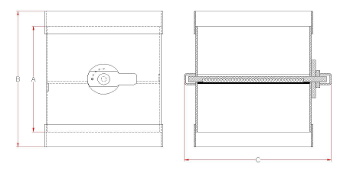

CPVC BUTTERFLY DAMPER SUBMITTAL INFORMATION

Model Number Nominal Duct Size Connection I.D. A* B* C*

D-CPVC-6 | 6 | 6.625 + 1/16 | 8 | 12 | 10.5
D-CPVC-7 | 7 | 7.375 + 1/16 | 8 | 12 | 11.3
D-CPVC-8 | 8 | 8.625 + 1/16 | 8 | 12 | 12.5
D-CPVC-9 | 9 | 9.375 + 1/16 | 10 | 14 | 13.2
D-CPVC-10 | 10 | 10.75 + 1/16 | 10 | 14 | 14.6
D-CPVC-12 | 12 | 12.75 + 1/16 | 12 | 16 | 16.6
D-CPVC-14 | 14 | 14 + 1/16 | 14 | 18 | 17.9
D-CPVC-16 | 16 | 16 + 1/16 | 16 | 20 | 20.3
D-CPVC-18 | 18 | 18 + 1/16 | 18 | 22 | 22.3
D-CPVC-20 | 20 | 20 + 1/16 | 20 | 26 | 24.3
D-CPVC-24 | 24 | 24 + 1/16 | 30 | 36 | 28.3

*Within ¼ Inch

