CPVC
Submittal Information
PVC Saddle Blast Gate

- Constructed from PVC Sheet and are Used
in Ventilation Systems

- Welded Construction using 5/32” PVC Welding
Rod

- All Dimensions in Inches

- All Dimensions are to CSSI Standards and are
Subject to change.

PRODUCT DIMENSIONS
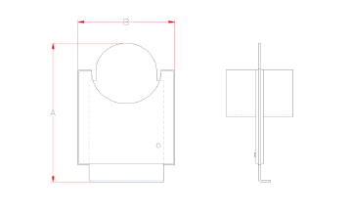
PVC SADDLE BLAST GATES SUBMITTAL INFORMATION

Model Number Nominal Duct Size OD Pipe Size A B

SBG-PVC-4 | 4 | 4.5 + 1/16 | 11.9687 | 7.75
SBG-PVC-6 | 6 | 6.625 + 1/16 | 14.0625 | 9.5
SBG-PVC-8 | 8 | 8.625 + 1/16 | 17.125 | 11.5
SBG-PVC-10 | 10 | 10.75 + 1/16 | 20.25 | 14
SBG-PVC-12 | 12 | 12.75 + 1/16 | 23.3125 | 16
SBG-PVC-14 | 14 | 14 + 1/16 | 26.375 | 17
SBG-PVC-16 | 16 | 16 + 1/16 | 29.25 | 19
SBG-PVC-18 | 18 | 18 + 1/16 | 32.3125 | 21.25
SBG-PVC-20 | 20 | 20 + 1/16 | 35.375 | 23.25
SBG-PVC-24 | 24 | 24 + 1/16 | 38.25 | 27.25

